Nombre del alumno: ______________________________________________________

|  |  |  |  |  |  |  |  |  |  |  |  |
| --- | --- | --- | --- | --- | --- | --- | --- | --- | --- | --- | --- |
| 1 | 2 | 3 | 4 | 5 | 6 | 7 | 8 | 9 | 10 | 11 | 12 |

Cuenta las figuras, y escribe la respuesta en el recuadro

|  |  |  |  |  |  |  |  |  |  |  |  |
| --- | --- | --- | --- | --- | --- | --- | --- | --- | --- | --- | --- |
| |  |  |  | | --- | --- | --- | |  | |  | | --- | |  | | |  | |  | | |  |  |  | | --- | --- | --- | |  | |  | | --- | |  | | |  | |  | |
| |  |  |  | | --- | --- | --- | |  | |  | | --- | |  | | |  | |  | | |  |  |  | | --- | --- | --- | |  | |  | | --- | |  | | |  | |  | |

|  |  |  |  |  |  |  |  |  |  |  |  |
| --- | --- | --- | --- | --- | --- | --- | --- | --- | --- | --- | --- |
| |  |  |  | | --- | --- | --- | |  | |  | | --- | |  | | |  | |  | | |  |  |  | | --- | --- | --- | |  | |  | | --- | |  | | |  | |  | |
| |  |  |  | | --- | --- | --- | |  | |  | | --- | |  | | |  | |  | | |  |  |  | | --- | --- | --- | |  | |  | | --- | |  | | |  | |

Rellena el Número que falta

|  |  |
| --- | --- |
| 3___5, 6, ____ | 8___10, 11, ___ |
| 9____, 11, ____ | 5____7, ____, 9____ |

|  |  |
| --- | --- |
| 6____, 8, 9____ | ____8, 9, ___11 |

Coloca el número que corresponde

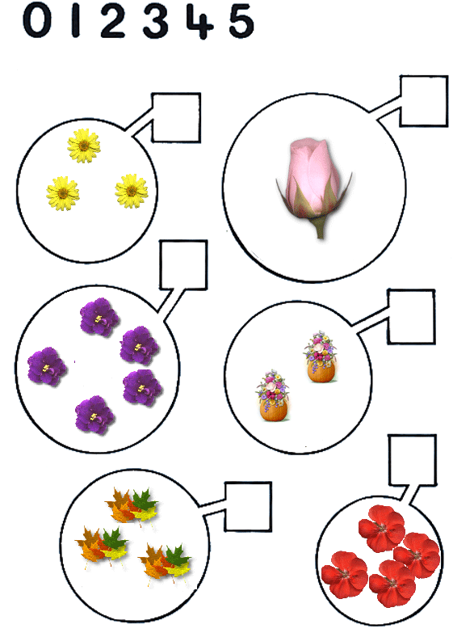

Coloca el número que falta

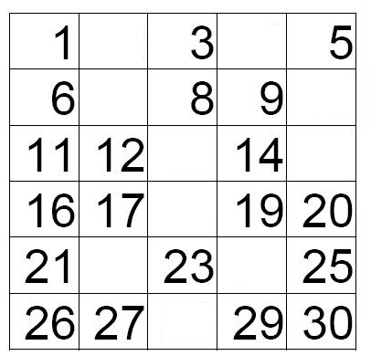

Resolver sumas

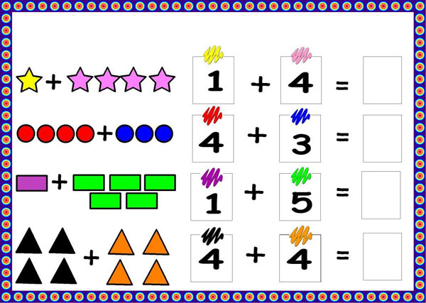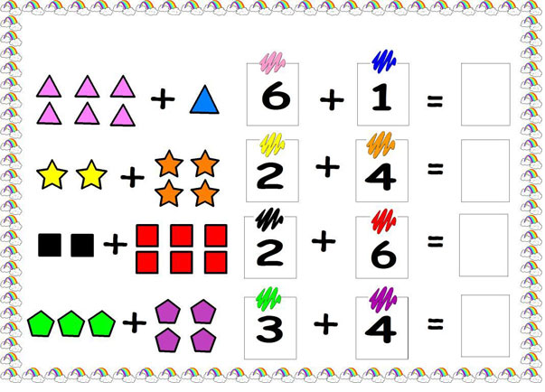

Suma los números y escribe la respuesta en el recuadro

|  |  |  |  |  |  |  |  |  |  |  |
| --- | --- | --- | --- | --- | --- | --- | --- | --- | --- | --- |
| 3   |  | | --- | |  | |  | | + | 4   |  | | --- | |  | |  | | |  | | --- | |  |   = |  | |
| 5   |  | | --- | |  | |  | | | + | 4   |  | | --- | |  | |  | | = | |  | | --- | |  | | |

|  |  |  |  |  |  |  |  |  |  |
| --- | --- | --- | --- | --- | --- | --- | --- | --- | --- |
| 4   |  | | --- | |  | |  | | + | 6   |  | | --- | |  | |  | | = | |  | | --- | |  | |

|  |  |  |  |  |  |  |  |  |  |  |  |
| --- | --- | --- | --- | --- | --- | --- | --- | --- | --- | --- | --- |
| 4   |  | | --- | |  | |  | | | + | 4   |  | | --- | |  | |  | | | = | |  | | --- | |  | |
|  | | |

Suma de dígitos de recta numérica

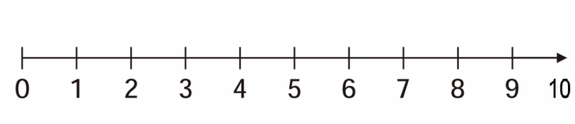

2+4=



4+4=



7+3=

Rodea con un círculo el grupo.

|  |  |  |
| --- | --- | --- |
| ¿Que tiene **menos**?   |  | | --- | |  |  |  | | --- | |  | |
| ¿Que tiene **más**?   |  | | --- | |  |  |  | | --- | |  | |

|  |  |  |  |
| --- | --- | --- | --- |
| Colorea **la figura del principio:**   |  | | --- | |  | | |  | | --- | |  | |

|  |  |  |  |
| --- | --- | --- | --- |
| Colorea **las 2 figuras del final:**   |  | | --- | |  | | |  | | --- | |  | |
| Colorea **las 2 figuras del centro:** | |  | | --- | |  | |

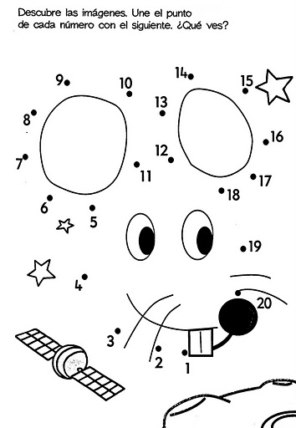

Colorea la manzana de rojo y verde como corresponde

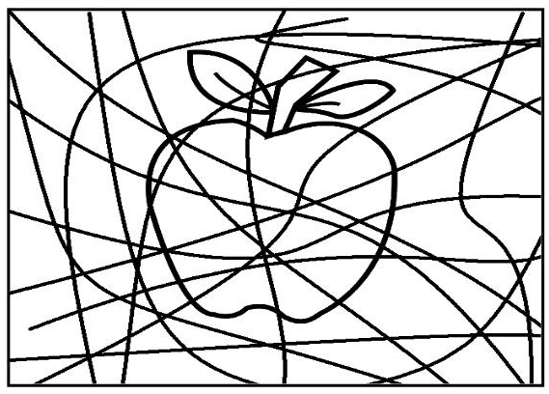

Colorea las figuras geométricas según corresponda el triangulo de color blue-azul, los círculos de color pink-rosa, los rectángulos de color Green-verde, los cuadrados de Orange-anaranjado y la estrella de color yellow-amarillo.

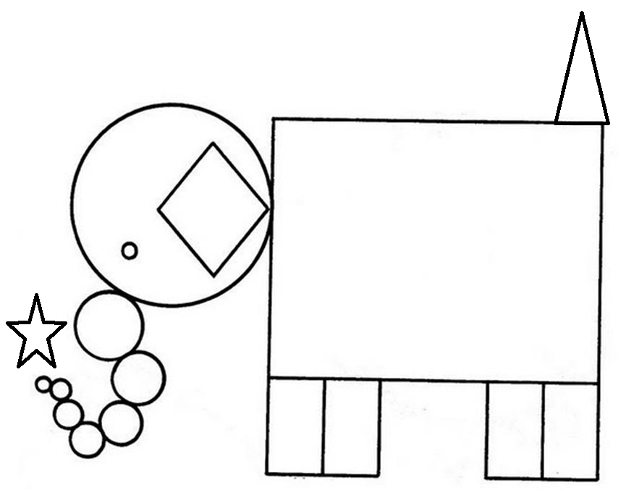

Trace a line black to help the animals in its destination (tracen una línea negra para ayudar a los animalitos en su destino)

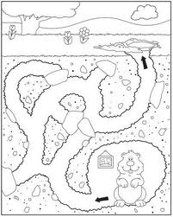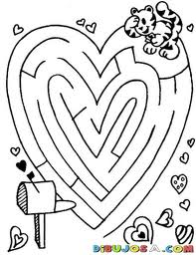

Paint the mouth red (pinta la boca de rojo)

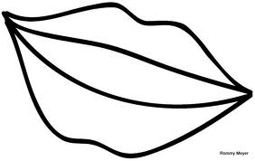

Paint the face happy and blemish la face sad (pinta la cara feliz y tacha la cara

Triste)

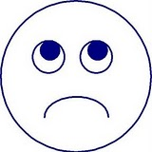

Colorea los dibujos que empiecen con la letra “Mm”

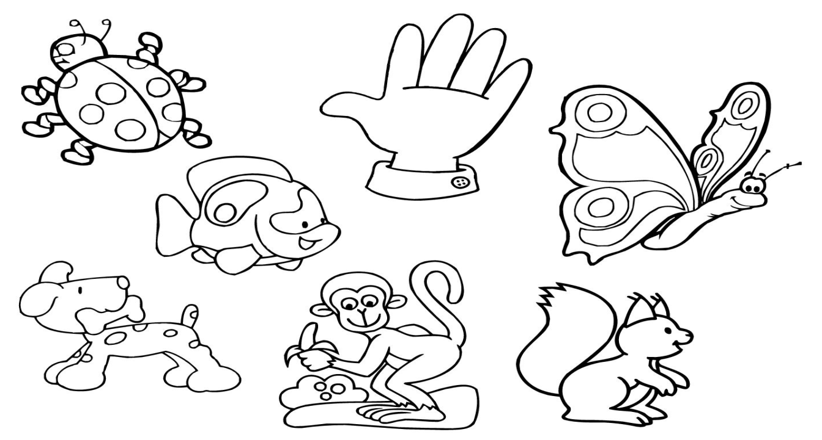

Encierra la silaba con la que inicien los siguientes dibujos mapa, molino, medalla, moto, migajas, muleta, muñeca, mesa, moneda, maracas, micrófono, maceta.

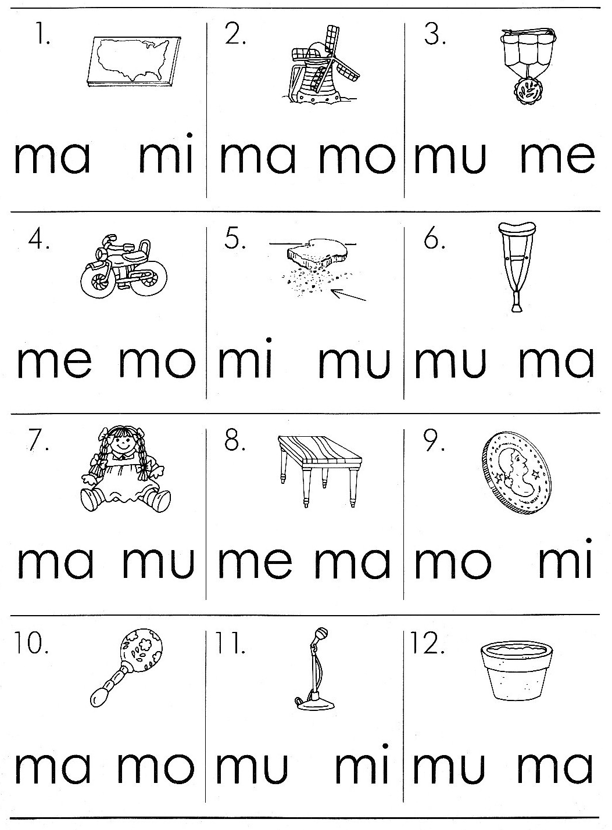

Coloca la silaba con la que inicia sa, se, si, so, su.

_______ _______ ________

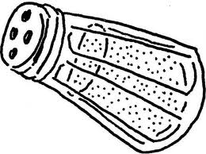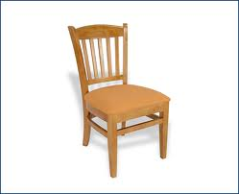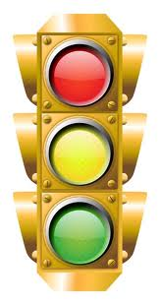

_________ __________

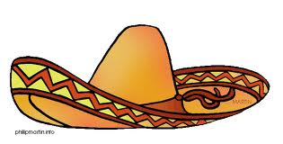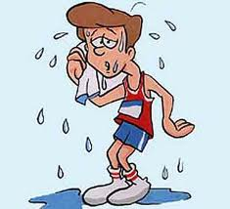

Coloca la silaba que corresponda

Toma____ _____mal ____tiza

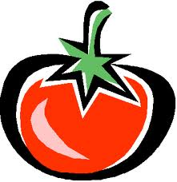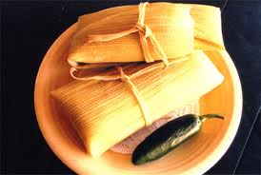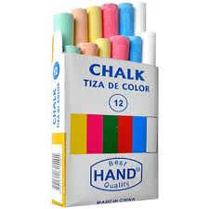

_______alla _____na

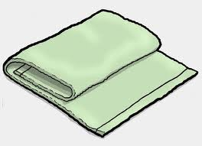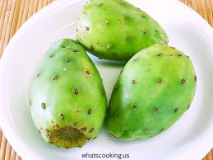

Coloca su nombre de cada imagen: mimo, mamá, mesa, suma, misa, Ema, museo, Mimí, memo, oso, Susi, masa, tomate, tose, te, meta.

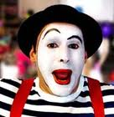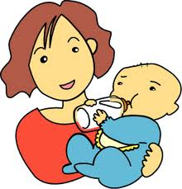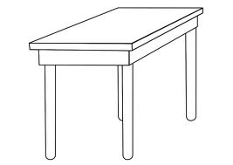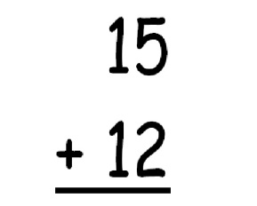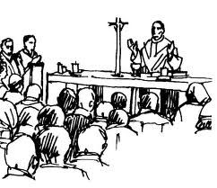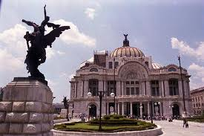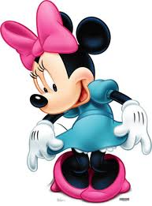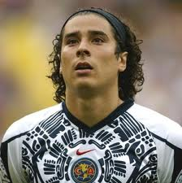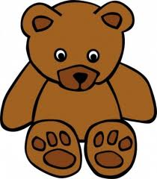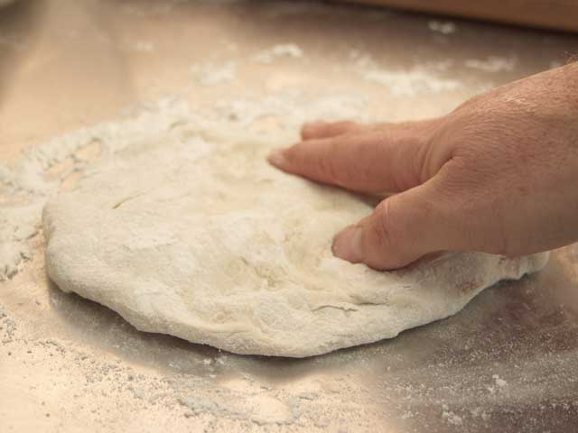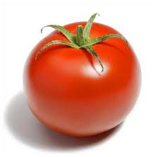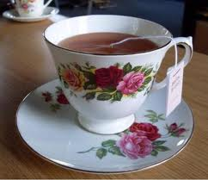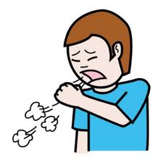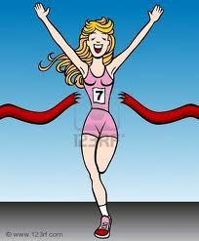

Observaciones: ________________________________________________________________________________________________________________________________________________________________________________________________________________________________________________________________________________________________________________________________________________________________________________________________________________________________________________________________________________________________________________________________________________________________________________